#### HUMAN BIOLOGICAL SCIENCES 2A

**FACTORS AFFECTING THE**

**MOTILITY OF EUGLENA**

**INVESTIGATION TWO**

Name: ___________________________________

Part A, Research: /15

Part B, Practical: /20

Part C, Assessment: /15

Total Marks: /50 %

**HBS2A: Investigation 2**

**Factors affecting the motility of Euglena**

You will be submitting three pieces of work for this investigation, which will run over approximately one week.

**Part A: Research - Lesson 1**

One period of class time will be allocated to researching the following:

1. What are Euglena? [1]
2. Both Euglena and sperm swim using a flagellum. Describe in detail how flagella work? [3]
3. Identify an optimum pH range for sperm and Euglena. [2]
4. Discuss three factors that affect sperm motility. [3]
5. Why is sperm motility important? [2]
6. Construct a table comparing and contrasting the characteristics of sperm and Euglena. Use the following headings: nucleus, specialised organelles/structures, location of flagellum, method(s) for obtaining nutrients [4]

This will be completed individually.

**Part B: Practical – Lesson 2 & 3**

Two periods of class time will be dedicated to completing the practical investigation on Euglena. The investigation procedure is attached. This practical will be completed in groups and the results are to be handed in for individual assessment.

**Part C: Validation Assessment – Lesson 4**

One period of class time following the practical investigation will be dedicated to an in-class validation test where you will be assessed on the information and results you have researched and formulated over the previous lessons. This will be completed individually and you will be able to use the results from your investigation.

**Part B: Practical**

**Factors affecting the motility of Euglena**

**Aim**

To investigate the effects of pH on the motility of Euglena.

**Equipment**

* Euglena culture
* Microscope
* pH solutions (4, 4.5, 5, 5.5 and 6)
* Glass slides and coverslips x5
* Permanent marker pen
* 6 pasteur pipettes (one for each pH solution and one for Euglena)

**Method**

1. Using a permanent marker, label each slide with a pH value (4, 4.5, 5, 5.5 and 6).
2. Place two drops of the appropriate pH solution on each slide. Use the correct pasteur pipette for each solution; do not mix up the pipettes.
3. Place two drops of Euglena solution on the pH 4 slide using the correct pipette.
4. Place a coverslip on the slide.
5. View the slide immediately. Focus using 40x magnification (lowest) and then go to 100x.
6. Estimate the percentage of motile (moving) Euglena in the field of view.
7. Move to another field of view and estimate the percentage of motile Euglena in this new field.
8. Repeat until you have sampled a total of five fields.
9. Examine the slide again at 5 minutes and 15 minutes and repeat steps 6-8.
10. Record all data in an appropriate format.
11. Repeat for each pH solution.

**Results and Discussion**

1. Present all of your results in a table. [5]
2. Identify the independent and dependent variables. [2]
3. List four control variables in this investigation and explain why it was necessary to control each one. [4]
4. Write a suitable hypothesis for this investigation. [2]
5. What conclusions can you draw from this investigation? Include in your answer a reason as to why pH might affect the efficiency of a flagellum [4]
6. This investigation aims to simulate sperm motility using live Euglena. Based on your research of sperm and Euglena, would you expect similar results if you had conducted this experiment using sperm? Explain your answer. [3]

**Part C: Validation Assessment**

**Factors affecting the motility of Euglena**

1. Why was it critical to use separate pipettes for each pH solution during your investigation into the effect of pH on Euglena motility? [1]
2. During the investigation you estimated the percentage of motile Euglena in five different fields of view for each pH solution. If you had digital photographs of each these fields of view, how could you use this information to improve the accuracy of your results? [1]
3. The diagram below shows a cross-section of a flagellum as viewed through an electron microscope. Use this diagram to help answers parts (a) and (b).

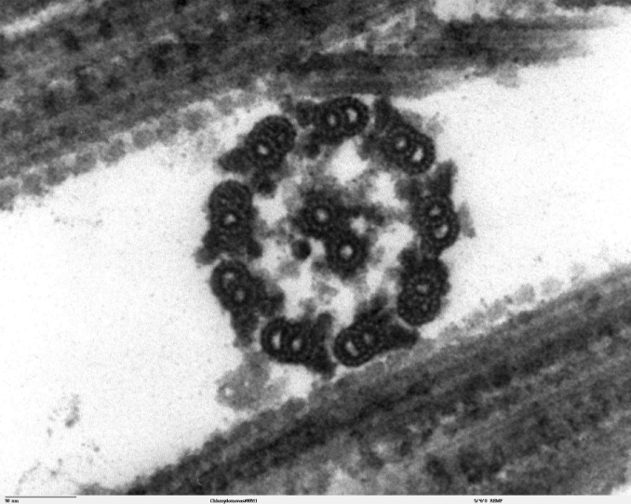

A

1. Name the structure label A. [1]
2. If the scale bar in the bottom left corner represents 50 nanometres, what is the diameter of the flagellum? Use the double headed arrow as a guide to the diameter. [1]
3. How does the location of the flagellum differ between a Euglena and a sperm? [1]
4. The following text describes another investigation into factors affecting the motility of Euglena. Use this information to help answers parts (a) to (e).

*Euglena were placed in solutions at various temperatures ranging from 10 to 42oC. After allowing 10 minutes for the Euglena to acclimatize to the solution, samples were placed onto slides for viewing under a microscope. Slides were viewed at 400x magnification and then two digital photographs were taken. The photographs were taken exactly 5 seconds apart using an electronic timer. By measuring the distance selected Euglena had travelled between the first and second photographs, their speed was calculated.*

The images below represent two of the photographs that were taken during the investigation for a solution at 18oC.

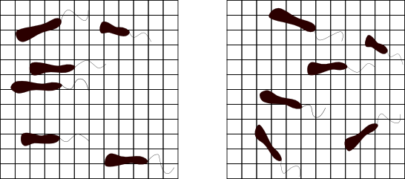

First Image (Time = 0 seconds)

Second Image (Time = 5 seconds)

**A**

**A**

**B**

**B**

**C**

**C**

Each square is 5 micrometres wide

1. Using the information in the images, calculate the speed of Euglena B. [1] Note the formula for calculating speed is distance (micrometres) divided by time (seconds).
2. A critical assumption of this experiment is that the selected Euglena travelled in a straight line between the two photographs. Is this a reasonable assumption for the Euglena B? Explain your answer. [1]

The table below shows the final results for the investigation.

|  |  |
| --- | --- |
| Temperature (oC) | Average speed (micrometres per second) |
| 10 | 2.97 |
| 18 | 3.61 |
| 26 | 3.50 |
| 34 | 3.47 |
| 42 | 3.12 |

1. Based on your calculation is the speed of Euglena B above or below average? [1]
2. What is the independent variable in this experiment? [1]
3. What conclusions can be drawn from this experiment? [2]
4. Describe why flagella are affected by temperatures or pH outside the optimum. [2]
5. Sperm generally die when exposed directly to vaginal fluid, however when semen mixes with vaginal fluid, the sperm swim better than in semen only. Explain why sperm swim best, a state called hypermotility, when in a mixture of semen and vaginal fluid. [2]